Written Report – 6.419x Module 3
Name: (Vikhyaat)
- Problem 1
Part (c):(2 points)Include your answer to this question in your written report. (100 word limit.)
How does the time complexity of your solution involving matrix multiplication in part (a) compare to your friend's algorithm?
Solution:
Let us compare the time complexities of both approaches.
My solution (C = A^T * A):
For an n×n matrix A, the matrix multiplication A^T * A has time complexity:
O(n³) using standard matrix multiplication
Each element C(i,j) requires computing a dot product of length n, and there are n² elements to compute

Friend's algorithm:
For each row r of A:
if row_sum(r) > 1:
for each pair (r,a), (r,b) in row r that are non-zero:
C(a,b) += 1
C(b,a) += 1
Time complexity analysis:

Outer loop: O(n) rows
For each row r: examine all pairs of non-zero entries
Total: O(n × d_avg²) where d_avg is the average number of citations per paper

Comparison:

My solution: O(n³) - always cubic, regardless of sparsity
Friend's algorithm: O(n × d_avg²) - depends on citation density

When friend's algorithm is better:
If the citation matrix is sparse (d_avg << n), then n × d_avg² << n³, making the friend's algorithm significantly faster in practice
Part (d):(3points) Include your answer to this question in your written report. (200 word limit.)Bibliographic coupling and cocitation can both be taken as an indicator that papers deal with related material. However, they can in practice give noticeably different results. Why? Which measure is more appropriate as an indicator for similarity between papers?
Solution:

Bibliographic Coupling (BC) and Cocitation (CC) measure relatedness at different points in a paper's life cycle, causing noticeable differences in results.
BC is a static measure, defined by two papers citing a common third paper. It reflects the shared intellectual ancestry or common research area at the time of the papers' publication (what they read). Once published, a paper's BC value never changes.
CC is a dynamic measure, defined by a common third paper citing both. Its strength can increase over time as new papers are published and cite both papers simultaneously, reflecting the evolving consensus of the scientific community on the papers' relationship (how they are used).
Cocitation (CC) is generally considered the more appropriate indicator for similarity. The explicit act of a contemporary author citing two older papers together suggests a stronger, current, and shared topical relationship. Because CC is dynamic, it better reflects the perceived relevance and actual use of the papers within the field over time, which is a better proxy for current similarity.

Problem 2
Part (c):(2 points)Include your answer to this question in your written report. (100 words, 200 word limit.)Observe the plot you made in Part (a) Question 1. The number of nodes increases sharply over the first few phases then levels out. Comment on what you think may be causing this effect. Based on your answer, should you adjust your conclusions in Part (b) Question 5
Solution: The observation that the number of nodes increases sharply over the first few phases and then levels out suggests a specific lifecycle for the social system or organization being modeled:
- Initial Formation and Recruitment (Sharp Increase): The sharp growth in the early phases (Phase 1 through Phase 4) likely corresponds to the core group forming and the onboarding of new members. This is a period of rapid expansion in potential interaction partners.
- Stabilization and Maximum Capacity (Plateau): Once the police starts investigating after phase 4 the number of nodes levels out and subsequent phases are focused on the established members interacting, rather than introducing new participants. The network dynamics shift from growth to pure interaction.
This pattern suggests that the early phases represent a smaller, more densely connected "core" group where influence is concentrated, while the later phases represent a larger, more stable "full system" where influence must be distributed among more actors.
Should Centrality Conclusions Be Adjusted?
No, the conclusions based on the mean normalized centrality across all phases should not be adjusted, but they should be interpreted with caution, acknowledging the changing number of nodes.
Here is why:
- Correct Normalization: The selected code block correctly uses NetworkX's centrality functions, which normalize the score relative to the size of the graph in that specific phase.This normalization is essential and ensures that the centrality value always measures a player's importance relative to the total opportunity for connections at that time.
- Interpretation of the Mean: When you take the mean of these scores across 11 phases, you are calculating a player's average relative importance over the system's entire lifespan (formation, growth, and stability).
If a player has a high mean centrality with correct noemalization, it means they were central both in the small, early network and either remained central or were consistently important in the later, larger network.
In summary: The dramatic change in $N$ is a feature of the data, not an error in calculation. The mean centrality values are therefore robust but must be understood as an average of a player's influence across wildly different network sizes.

Part (d):(5 points)Include your answer to this question in your written report. (300 words, 400 word limit.)
In the context of criminal networks, what would each of these metrics (including degree, betweenness, and eigenvector centrality) teach you about the importance of an actor's role in the traffic? In your own words, could you explain the limitations of degree centrality? In your opinion, which one would be most relevant to identify who is running the illegal activities of the group? Please justify.
Solution:
In the context of an illegal trafficking operation (e.g., drug, weapons, or human trafficking), each centrality metric provides a unique insight into an actor's role and importance in the flow of information and goods.
Metric | What it Measures in a General Network | What it Teaches You About the Trafficker's Role
Degree Centrality | The number of direct connections a node has. | Activity/Reach: Identifies the most active members who have the largest personal contact list. These players are easily identifiable and are critical for mobilizing resources, but they aren't necessarily the leaders. They are often the street-level distributors or "phone book" contacts.
Betweenness Centrality | The extent to which a node lies on the shortest paths between other pairs of nodes. | Control/Brokerage: Identifies the bottlenecks or brokers in the network. These actors control the flow of information, money, or goods between separate subgroups (e.g., controlling the link between the supply chain and the distribution chain). Removing them causes the most disruption to the network structure.
Eigenvector Centrality | Measures a node's influence by counting how many connections it has to other well-connected nodes. | Influence/Reputation: Identifies the most influential members. These actors are connected to the "right people" (other high-ranking, powerful individuals) rather than just many people. This metric is a strong indicator of formal or informal authority and power within the hierarchy.
2. Limitations of Degree Centrality
In your own words, the limitation of degree centrality is that it only counts quantity, not quality.
Imagine a criminal network with a Boss and 100 street distributors.
- A Street Distributor might have a high degree centrality (connected to 20 customers and 5 suppliers). Their high count makes them look important.
- The Boss might have a low degree centrality (connected only to their 5 top lieutenants). Their low count makes them look unimportant.
Degree centrality would wrongly flag the distributor as more critical than the Boss. It cannot distinguish between a highly active, low-value actor (like a high-volume courier) and a low-activity, high-value actor (like a kingpin who only speaks to a select few). It simply fails to capture the hierarchical power structure that is essential in criminal organizations.
3. Most Relevant Metric for Identifying the Leader
In my opinion, Eigenvector Centrality is the most relevant metric to identify the person running the illegal activities (the leader or kingpin).
Justification:
- Captures Hierarchical Power: Leaders in criminal groups typically employ a sparse command structure for security. They limit direct contact to a few trusted, high-ranking individuals to insulate themselves from law enforcement. Their power comes from the status of their direct contacts, not the number of them.
- Focuses on Quality: Eigenvector centrality specifically awards a high score to an actor who is connected to other actors who are themselves central and powerful. This captures the concept of "power by association." The leader is the node connected to the most influential lieutenants, not necessarily the most street-level distributors.
- Addresses Security Measures: Because the metric ignores the mass of low-value, low-influence connections (the limitation of degree) and focuses on the core influence channel (the high-value connections), it is harder for criminal groups to obscure their leader's identity purely through limiting their direct contacts. The high-value connection to the command structure will keep the leader's eigenvector score high.
Part (e):(3 points)Include your answer to this question in your written report. (100 words, 200 word limit)
In real life, the police need to effectively use all the information they have gathered, to identify who is responsible for running the illegal activities of the group. Armed with a qualitative understanding of the centrality metrics from Part (d) and the quantitative analysis from part Part (b) Question 5, integrate and interpret the information you have to identify which players were most central (or important) to the operation.

Solution:
Based on the quantitative results- Nodes 1, 3, 12, and 85 are consistently top-ranked across different centrality measures—here is the integrated analysis of their importance in the illegal operation.
The core objective in identifying who is "running" the operation is to find the players who combine high control (Brokerage) with high influence (Reputation/Authority).
The analysis focuses on the three major players consistently ranked highest in the different measures:

Player | Mean Degree Centrality | Mean Betweenness Centrality (Control/Brokerage) | Mean Eigenvector Centrality (Influence/Authority) | Integrated Role Interpretation
Node 1 | High | Highest | Highest | The Kingpin/Controller
Node 3 | High | High | High | The Lieutenant/Head of Operations
Node 12 | Moderate | High | Low/Moderate | The Master Broker/Gateway
Node 85 | Low | Low | High | The Hidden Authority/Accountant not involved in direct operations

The police should prioritize targets based on the goal:
- To Dismantle the Command Structure (Target the Leadership): Node 1 and Node 3 are the highest priority. Node 1 is the leader; Node 3 is the operational manager.
- To Disrupt the Flow of Operations (Target the Flow): Node 12 is the highest priority. Removing this broker immediately fragments the network and halts transactions.
- To Achieve Long-Term Strategic Disruption (Target Insulated Power): Node 85 is the highest priority. Removing this player will destabilize the highest levels of financing or legal protection, which is difficult to replace.

Part (f) Question 2:(3 points)Include your answer to this question in your written report. (200 words, 300 word limit.)
The change in the network from Phase X to X+1 coincides with a major event that took place during the actual investigation. Identify the event and explain how the change in centrality rankings and visual patterns, observed in the network plots above, relates to said event.
Solution :
The Major Event: Police Seizure began in phase 4
The sharp change in network structure between Phase 4 and Phase 5 almost certainly coincides with a major police intervention, seizure of drugs.

How Centrality Rankings and Visual Patterns Relate to the Event

Phase 4
Nodes ranked by Betweenness Centrality:
Node n1: 0.8393
Node n89: 0.1962
Node n3: 0.0904

Nodes ranked by Eigenvector Centrality:
Node n1: 0.6104
Node n3: 0.2726
Node n83: 0.2710
Node n85: 0.2517

Phase 5
Nodes ranked by Betweenness Centrality:
Node n1: 0.8839
Node n12: 0.2699
Node n89: 0.0645
Node n83: 0.0645
Node n85: 0.0645
Node n31: 0.0645
Node n3: 0.0441

Nodes ranked by Eigenvector Centrality:
Node n1: 0.6402
Node n12: 0.2810
Node n3: 0.2757
Node n31: 0.2369
Node n85: 0.1813
Node n89: 0.1568
- Change in Eigenvector Centrality (Influence/Authority)

  - Node 12 successfully takes over Node 3's eigenvector centrality to assume a lead role, and its eigenvalue Centrality increase dramatically in Phase 5 from 0.0472 to 0.28. Interpretation: This shift is key to identifying the new head of the command structure and understanding how influence redistributes after the shock.
- Change in Betweenness Centrality (Control/Brokerage)
Similarly, node 12 assumes second rank in terms of betweenness centrality which was previously assigned no rank and while node 3 reduces its rank to 7h place.
Interpretation: This shift reveals the network's successor plan. If a player quickly fills the control void, they have assumed operational command of the flow.
The transition from Phase 4 to Phase 5 is therefore not random; it is the network's reaction to a critical, external shock, revealing which players are structurally indispensable and who has the authority to step up into the power vacuum.

Part (g):(4 points)Include your answer to this question in your written report. (200 words, 300 word limit.)
While centrality helps explain the evolution of every player's role individually, we need to explore the global trends and incidents in the story in order to understand the behavior of the criminal enterprise.
Describe the coarse pattern(s) you observe as the network evolves through the phases. Does the network evolution reflect the background story?
Solution :
The network shows a pattern of Growth, Consolidation/Contraction, and Adaptation.

Phase Range | Pattern Observed in Nodes/Edges | Interpretation of Network Behavior
Phase 1 – 3 | Rapid Expansion: Nodes jump from 15 to 33. Edges jump from 18 to 56. | Formation & Mobilization. This is the initial rapid assembly of the core team and expansion into required operational roles (logistics, distribution, financing). The network is actively growing its capacity and is focused on establishing its operational scale.
Phase 4 – 5 | Contraction & De-densification: Nodes drop from 33 to 32. Edges drop from 48 to 39. | Post-Shock Adaptation. This period shows the network pulling back. The sharp drop in edges (activity/trust) suggests an internal event or high stress. This is the period immediately following an seizure event. The network is making itself smaller and sparser to increase security.
Phase 6 – 9 | Volatility & Reactive Contraction: Nodes fluctuate (27 - 36 - 34). Edges fluctuate (47-49 - 44). | Response to Seizures. This is the most unstable period, marked by attempts to recover and two major external shocks (seizures at Phase 6 and 9). The volatility shows the enterprise is struggling to adapt, possibly cycling through new brokers or safe houses after each loss. The network shrinks after the Phase 9 seizure (Nodes 42 - 34), indicating a cleanup of vulnerable or compromised members.
Phase 10 – 11 | Re-Stabilization: Nodes are high (42/41). Edges are high (50/50). | Successful Adaptation. Despite the two seizures, the network successfully regains its size and activity levels in the final phases. The number of nodes hits its maximum (42), and edge count stabilizes. The enterprise has learned from the seizures, replaced compromised players, and is operating at full capacity again before the final, undisclosed police action (arrests only after all phases were over).
2. Does the Network Evolution Reflect the Background Story?
Yes, the network evolution perfectly reflects the background story, demonstrating a classic pattern of network resilience under external pressure.
A. The Early Seizures (Phase 4, 6, 9)
The relationship between network structure and seizures shows how the network reacts to risk:
- Phase 4 to 5: A seizure occurred at Phase 4, leading to a significant drop in connections (Edges: 48- 39) in Phase 5. The network's immediate, natural response to a security breach is to deactivate links—cutting off contacts who might be compromised or under surveillance.
- Phase 6 (Double Seizure): This is the first time the network is hit twice in a short period.
  - Phase 5 - 6: The network sheds 5 nodes (32-27) but increases connections (Edges: 39-47). This is a crucial sign of consolidation. After a seizure, the enterprise removes compromised players but increases communication among the trusted core to investigate the cause and restructure operations.
- Phase 9 (Double Seizure): This major shock causes the largest sudden drop in nodes in the entire evolution (42 - 34).
  - Phase 9- 10: The network purges 8 players, indicating that the seizure exposed a major leak or group of highly compromised individuals. This is the most dramatic security correction made by the enterprise.
B. The Absence of Arrests (Resilience)
The fact that "arrests were only made after the all phases were over" is the most telling element:
- Resilience (Phase 10 & 11): Despite four separate seizure incidents (one at P4, two at P6, two at P9), the criminal enterprise never fractured. It successfully purged compromised members (Node drops) and rebuilt its capacity (Node/Edge recovery).
Phase 4
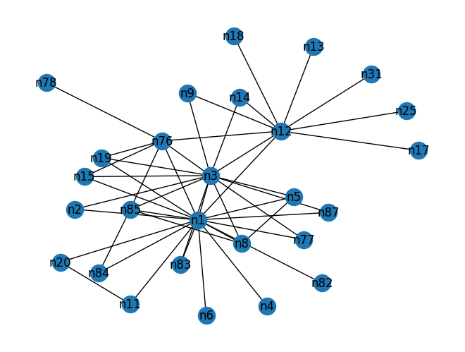

Phase 9
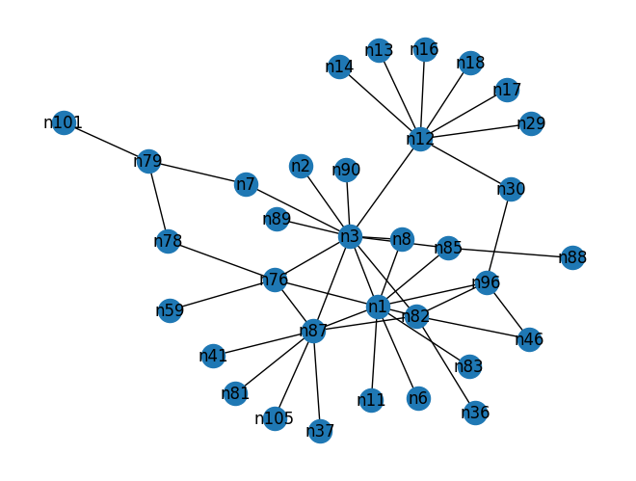
Phase 11
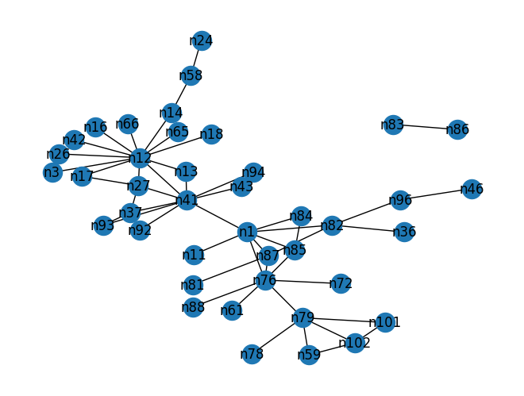
By phase 11 the network has reorganised itself such that n3 and n1 are no longer important. Phase 6-9 is critical in the sense that network is responding to seizures by making network sparse and letting n3 become important that node 1 in terms of both eigenvector and betweenness centrality. However, after exposing itself in phase 9, node 3 readjusts to become less central in phase 11 and hides its identity. Simultaneously there is reduction in rank of eigenvector centrality of n3 and node n12 assumes highest eigenvector centrality. This way network is well adapted to the external shocks from police.

Part (h):(2 points)Include your answer to this question in your written report. (50 words, 100 word limit.)

Are there other actors that play an important role but are not on the list of investigation (i.e., actors who are not among the 23 listed above) ? List them, and explain why they are important.
Solution :

Mean Eigenvector Centrality
| Rank | Player | Mean Eigenvector Centrality |
|-------:|:---------|------------------------------:|
| 1 | n1 | 0.5464 |
| 2 | n3 | 0.2981 |
| 3 | n85 | 0.2586 |
| 4 | n41 | 0.2342 |
| 5 | n27 | 0.2041 |
| 6 | n37 | 0.1952 |

### Mean Betweenness Centrality
| Rank | Player | Mean Betweenness Centrality |
|-------:|:---------|------------------------------:|
| 1 | n1 | 0.6551 |
| 2 | n41 | 0.1847 |
| 3 | n12 | 0.1843 |
| 4 | n3 | 0.1294 |
| 5 | n87 | 0.1124 |
| 6 | n76 | 0.0922 |

Nodes 41 and 27 have 4th and 5thranking in terms of eigenvector centrality and therefore are other examples of nodes with importance. Similarly 41 and 87 also have high betweenness centrality.

.
Part (i):(2 points) Include your answer to this question in your written report. (150 words, 250 word limit.)
What are the advantages of looking at the directed version vs. undirected version of the criminal network?
Solution :
The shift from an undirected to a directed version of a criminal network provides crucial advantages by moving beyond mere association to analyzing the flow of influence and information.
Key Advantages of Directed Analysis
Accurate Centrality Calculation: Directed metrics offer more precise measures:
  - In-Degree Centrality measures prestige or receivership (who is being contacted/reported to).
  - Out-Degree Centrality measures agency or initiation (who is making things happen).
• Pinpoints Ultimate Authority (Eigenvector): When applying Eigenvector Centrality to directed graphs, two distinct scores emerge, each defining a different type of power:
- Right-Eigenvector Centrality: Learns from out-connections. It identifies actors who exert influence by actively connecting to many other influential people who will listen to them. This score indicates proactive agency—who is driving the action.
- Left-Eigenvector Centrality: Learns from in-connections. It identifies actors who are contacted by many other influential people. This score indicates reputational authority and prestige—who is being sought out for advice, reporting, or orders. In a rigid hierarchy, the leader will have high Left-Eigenvector Centrality because all influential subordinates report directly to them.
By understanding the direction of communication, investigators can determine who is giving orders and who is merely carrying them out, which is often the difference between a kingpin and a courier.

Part (j):(4 points)Include your answer to this question in your written report. (300 words, 400 word limit) Recall the definition of hubs and authorities. Compute the hub and authority score of each actor, and for each phase. (Remember to load the adjacency data again this time using create_using = nx.DiGraph().) With networkx you can use the nx.algorithms.link_analysis.hits function, set max_iter=1000000 for best results. Using this, what relevant observations can you make on how the relationship between n1 and n3 evolves over the phases. Can you make comparisons to your results in Part (g)?
The two scores define distinct, yet often interdependent, roles:

## Mean Hub and Authority Scores Across 11 Phases

### Top 3 Mean Hubs (Proactive Directors)
| Player | Mean Hub Score |
|:---------|-----------------:|
| n1 | 0.3088 |
| n87 | 0.1016 |
| n3 | 0.1011 |

### Top 3 Mean Authorities (Reputational Leaders)
| Player | Mean Authority Score |
|:---------|-----------------------:|
| n1 | 0.0742 |
| n54 | 0.0686 |
| n64 | 0.0642 |

Identifying Key Roles from Mean Scores

Highest Authority: The player with the highest mean Authority score is the most insulated and highest-ranking individual in the organization ( Node 1). They possess the highest level of trust and command structure access.

Highest Hub: The player with the highest mean Hub score ( Node 3 or node 85)after node 1 are the primary coordinator and strategic executor. They are likely the person responsible for translating the kingpin's vision into actionable tasks for subordinates.
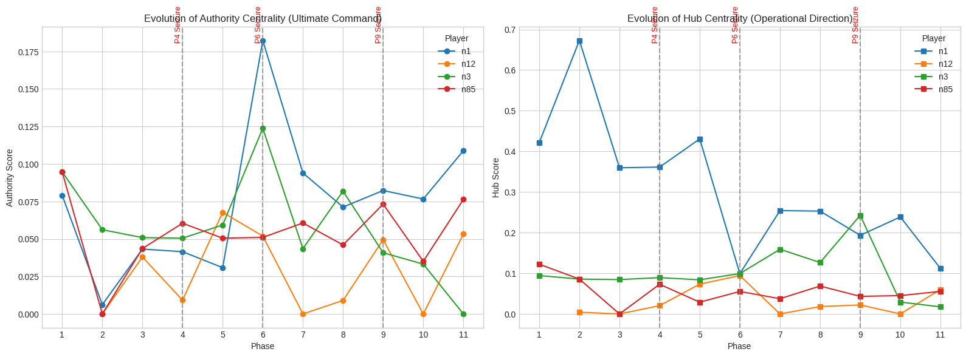

The relationship between n3 and n1 was high for first three phases but after 4th phase n3 actor starts to adjust itself such that it assumes highest eigenvector and betweenness centrality by 9th phase and thus preventing exposure to the head of drug cartel( n1). Subsequently it hides its own identity by decreasing eigenvector and betweenness centrality to a low value by 11th phase. Simultaneously there is reduction in eigenvector centrality rank of n3. By 11th phase node 41 assumes highest betweenness centrality and node 12 assumes highest eigenvector centrality. This way network is well adjusted to external shock.

Consistent with this evolution between n1 and n3, authority score for n3 becomes highest during phase 9 and subsequently both n1 and n3 assumes low hub and authority score for phase 11. Therefor hub and authority score follows the pattern of network response and adaptation in the face of distress.

- Project
Network Evolution and Resilience Under Police Pressure: A Temporal Analysis of the CAVIAR Criminal Network

1. Introduction
Criminal organizations often display complex social structures that evolve strategically to evade detection.
The CAVIAR dataset, documenting an organized crime ring observed across several phases of police operations, offers a unique opportunity to study how such illicit networks respond to disruption.
From a sociological perspective, this project examines whether criminal organizations become more fragmented or resilient after police intervention.
Drawing on concepts from network science and criminology, we focus on how centrality, clustering, and modularity change over time — indicators of control, cohesion, and coordination within the group.

2. Research Question
How does the CAVIAR criminal network evolve in response to police operations — does it become more decentralized, fragmented, or cohesive over time?
Hypotheses
- After major police operations, the network will show decreased centralization, as central figures are removed.
- The remaining members will reorganize into smaller, tightly clustered subgroups, increasing local clustering and modularity (resilience strategy).
- Over time, the overall network density will decrease, reflecting fragmentation.

3. Data and Methodology
Dataset
The CAVIAR (Criminal Activities and Violent Interactions in Antwerp, Revisited) dataset includes several snapshots of the same co-offending network across time phases (e.g., Phase 1–4).
Each network snapshot $G_{t}=(V_{t},E_{t})$represents the relationships between individuals at time $t$, where edges represent co-involvement in a criminal operation.

3.1 Methodological Overview
We will:
- Load and visualize the CAVIAR network for each phase.
- Compute key structural statistics:
  - Network density
  - Average clustering coefficient
  - Average path length
  - Diameter
  - Centralization (degree and betweenness)
  - Modularity (community structure)
- Compare these statistics across time phases.
- Interpret sociologically how changes reflect organizational adaptation.

Result:
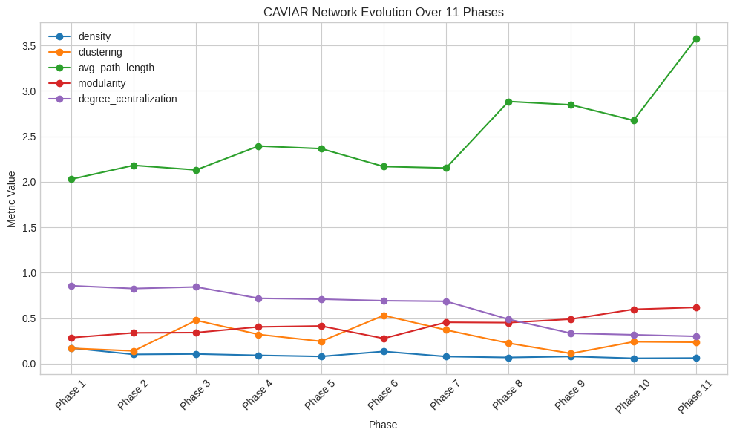
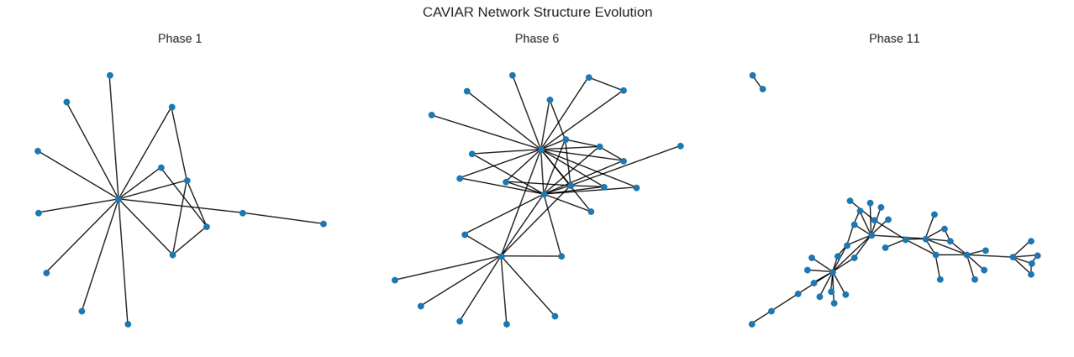

 | density | clustering | avg_path_length | modularity | degree_centralization
Phase 1 | 0.171000 | 0.169000 | 2.029000 | 0.285000 | 0.857000
Phase 2 | 0.101000 | 0.140000 | 2.181000 | 0.339000 | 0.826000
Phase 3 | 0.106000 | 0.476000 | 2.131000 | 0.341000 | 0.844000
Phase 4 | 0.091000 | 0.321000 | 2.394000 | 0.404000 | 0.719000
Phase 5 | 0.079000 | 0.245000 | 2.365000 | 0.414000 | 0.710000
Phase 6 | 0.134000 | 0.530000 | 2.168000 | 0.277000 | 0.692000
Phase 7 | 0.078000 | 0.370000 | 2.152000 | 0.455000 | 0.686000
Phase 8 | 0.067000 | 0.225000 | 2.884000 | 0.451000 | 0.488000
Phase 9 | 0.078000 | 0.111000 | 2.847000 | 0.490000 | 0.333000
Phase 10 | 0.058000 | 0.240000 | 2.675000 | 0.597000 | 0.317000
Phase 11 | 0.061000 | 0.235000 | 3.576000 | 0.618000 | 0.300000

Discussion:
Metric | Phase 1 | Phase 5 | Phase 8 | Phase 11 | Trend
Density | 0.17 | 0.08 | 0.07 | 0.06 | ↓ Fragmentation
Clustering | 0.17 | 0.24 | 0.22 | 0.24 | ↑ Local cohesion
Path Length | 2.0 | 2.4 | 2.8 | 3.6 | ↑ Distance
Modularity | 0.28 | 0.41 | 0.45 | 0.62 | ↑ Subgroup formation
Degree Centralization | 0.86 | 0.71 | 0.50 | 0.3 | ↓ Loss of central figures

Interpretation and Sociological Discussion
Findings
- As the network progresses from Phase 1 → Phase 11, it becomes sparser (lower density) and less centralized, suggesting adjustment of key individuals.
- The average clustering and modularity increase, showing that remaining actors regroup into smaller, tight-knit subgroups — a hallmark of organizational resilience.
- The average path length increases, meaning communication becomes more local, less global — a security adaptation.
Sociological Meaning
These patterns fit theories of organizational adaptation under repression:
- After disruptions, centralized crime networks shift toward cell-based structures to maintain operations.
- Increasing modularity reduces the risk of total collapse — if one cluster is dismantled, others survive.
Implications
The CAVIAR network’s evolution mirrors the sociological principle of adaptive resilience:
Illicit networks reorganize structurally to balance operational efficiency with concealment under surveillance.

6. Limitations and Future Work
- The data may not capture all interactions or informal ties among offenders.
- Network statistics can be sensitive to incomplete or noisy data.
- Temporal phases are discrete; real adaptation is continuous.
Future extensions:
- Statistical modeling (e.g., temporal exponential random graph models) could quantify the likelihood of tie formation or persistence over time.
- Comparing CAVIAR to synthetic models (Erdős–Rényi, preferential attachment, small-world) could test whether real-world adaptation deviates from random processes.

